1.create the table

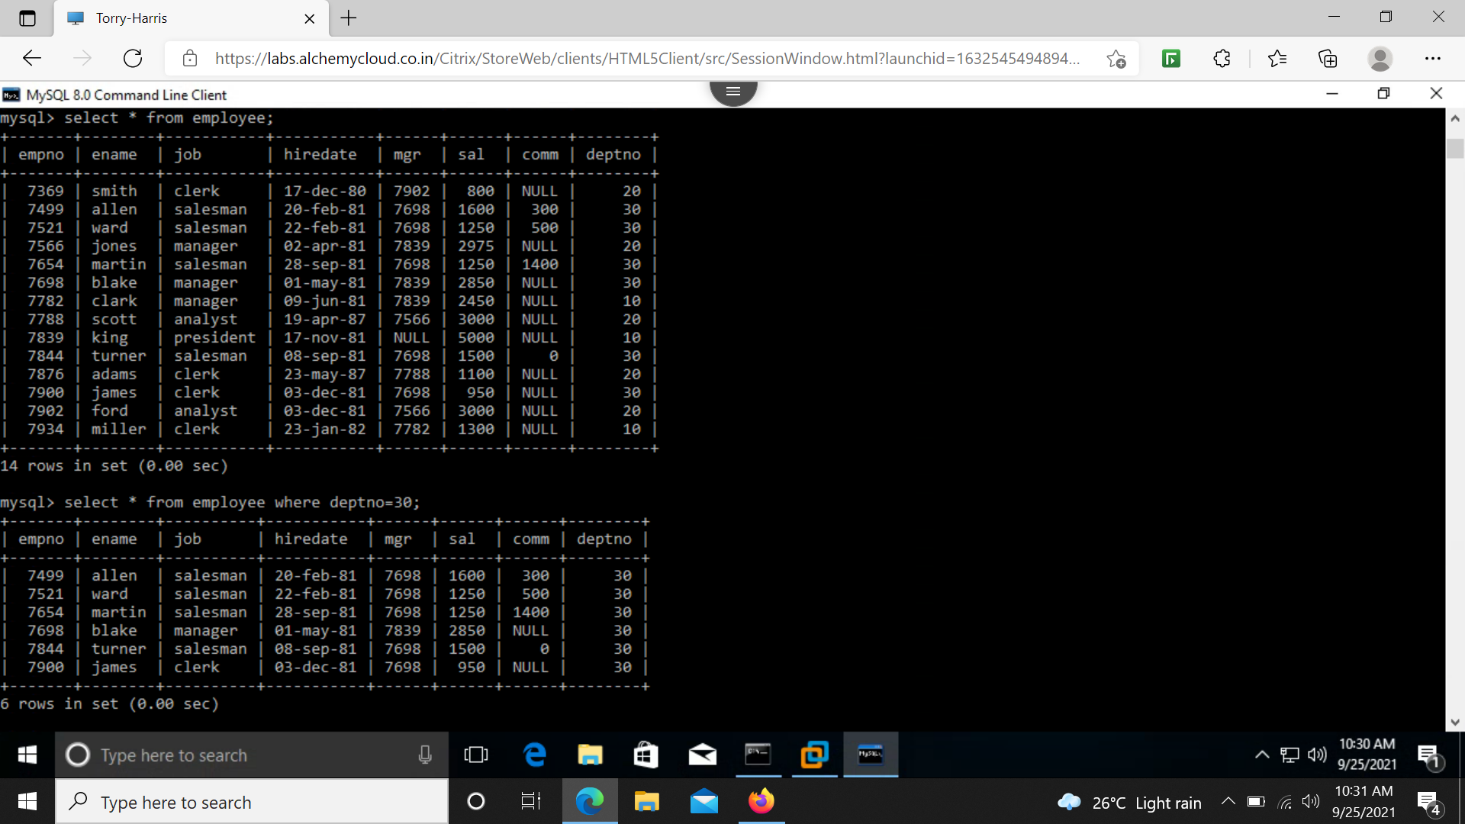

2.select the employee in department 30.



3.list the names,numbers and ddepartments of all clerks.

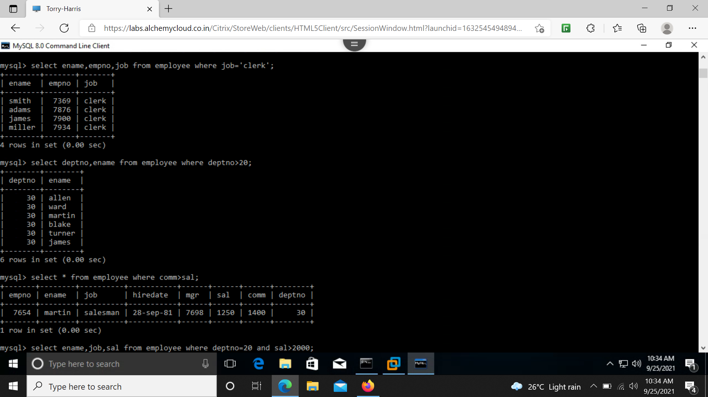

4.find the department numbers and names of employess of all department with deptno greater than 20.



5.find the employee whose commission is greater than their salaries.



6.find the employees whose commission is greater than 60% of their salaries.

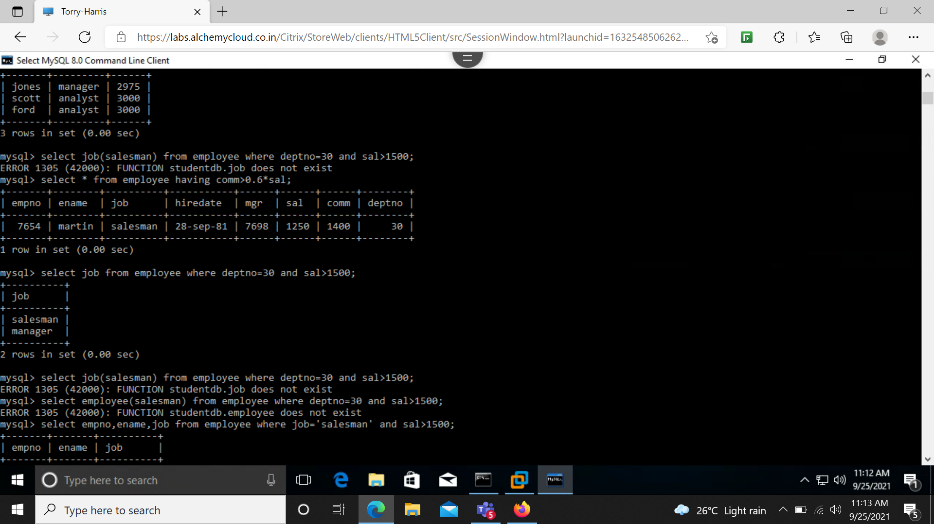

7.List name,jod,salary of all the employees in department 20 who earn more than 2000/-.

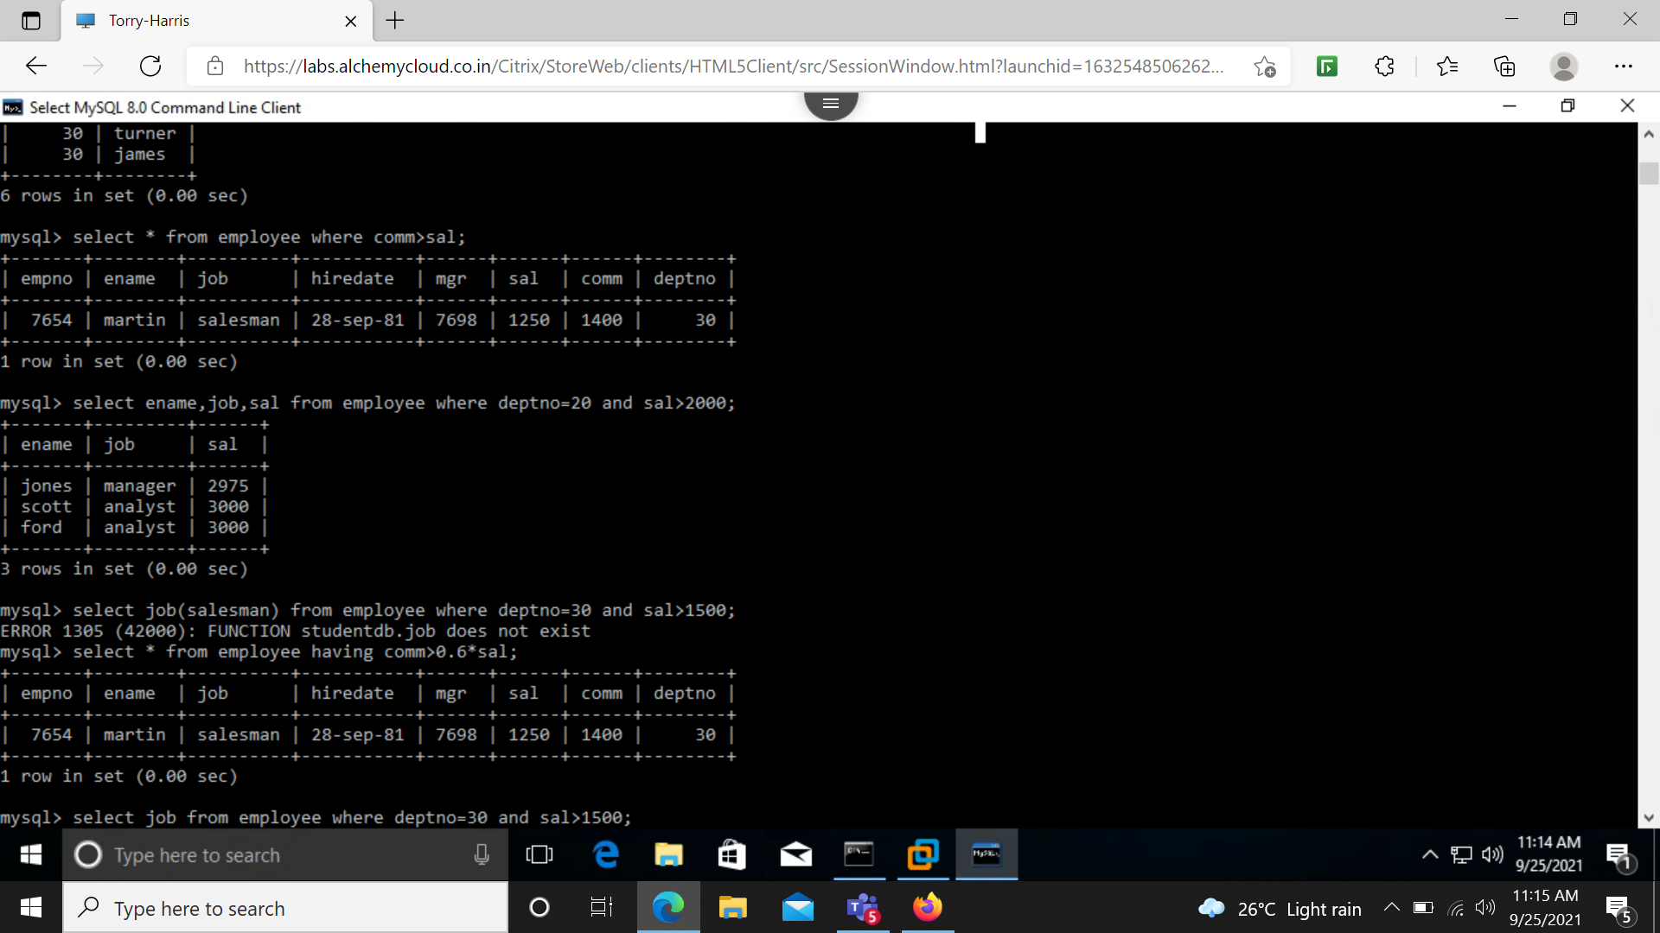

8.Find all salesman in department 30 whose salary is greater than 1500/-.

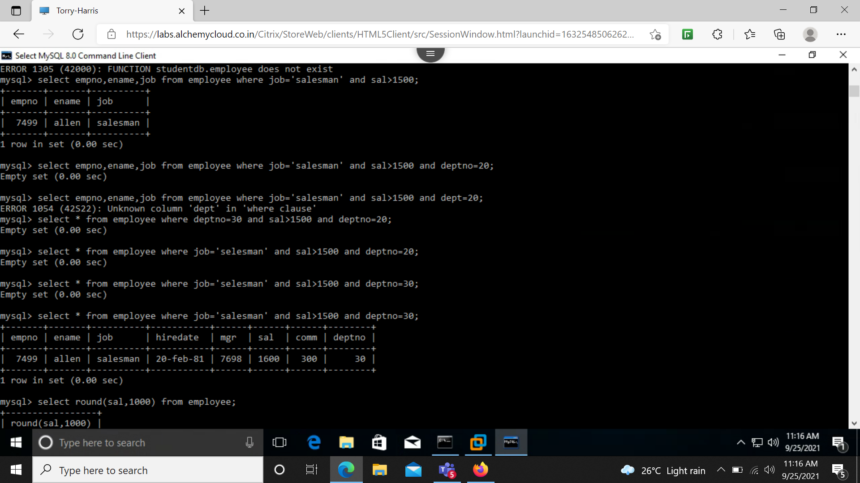

9.find all employees whose designation is either manager or president.

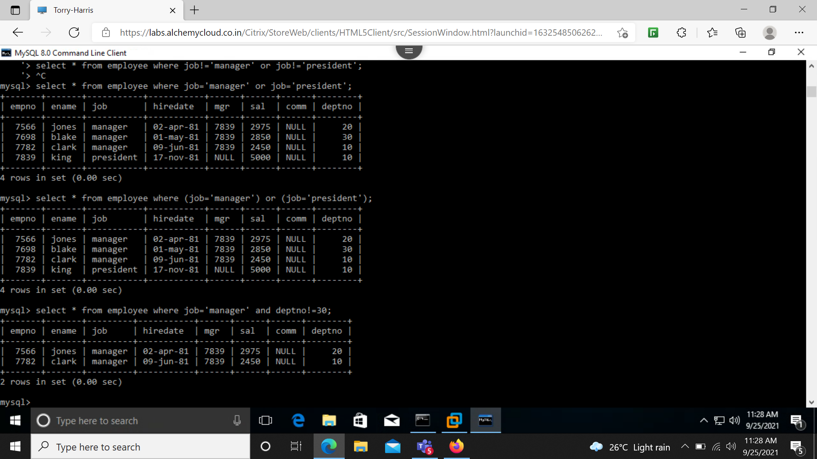

10.find all managers who are not in department 30.



11.find all details of managers and clerks in dept 10.

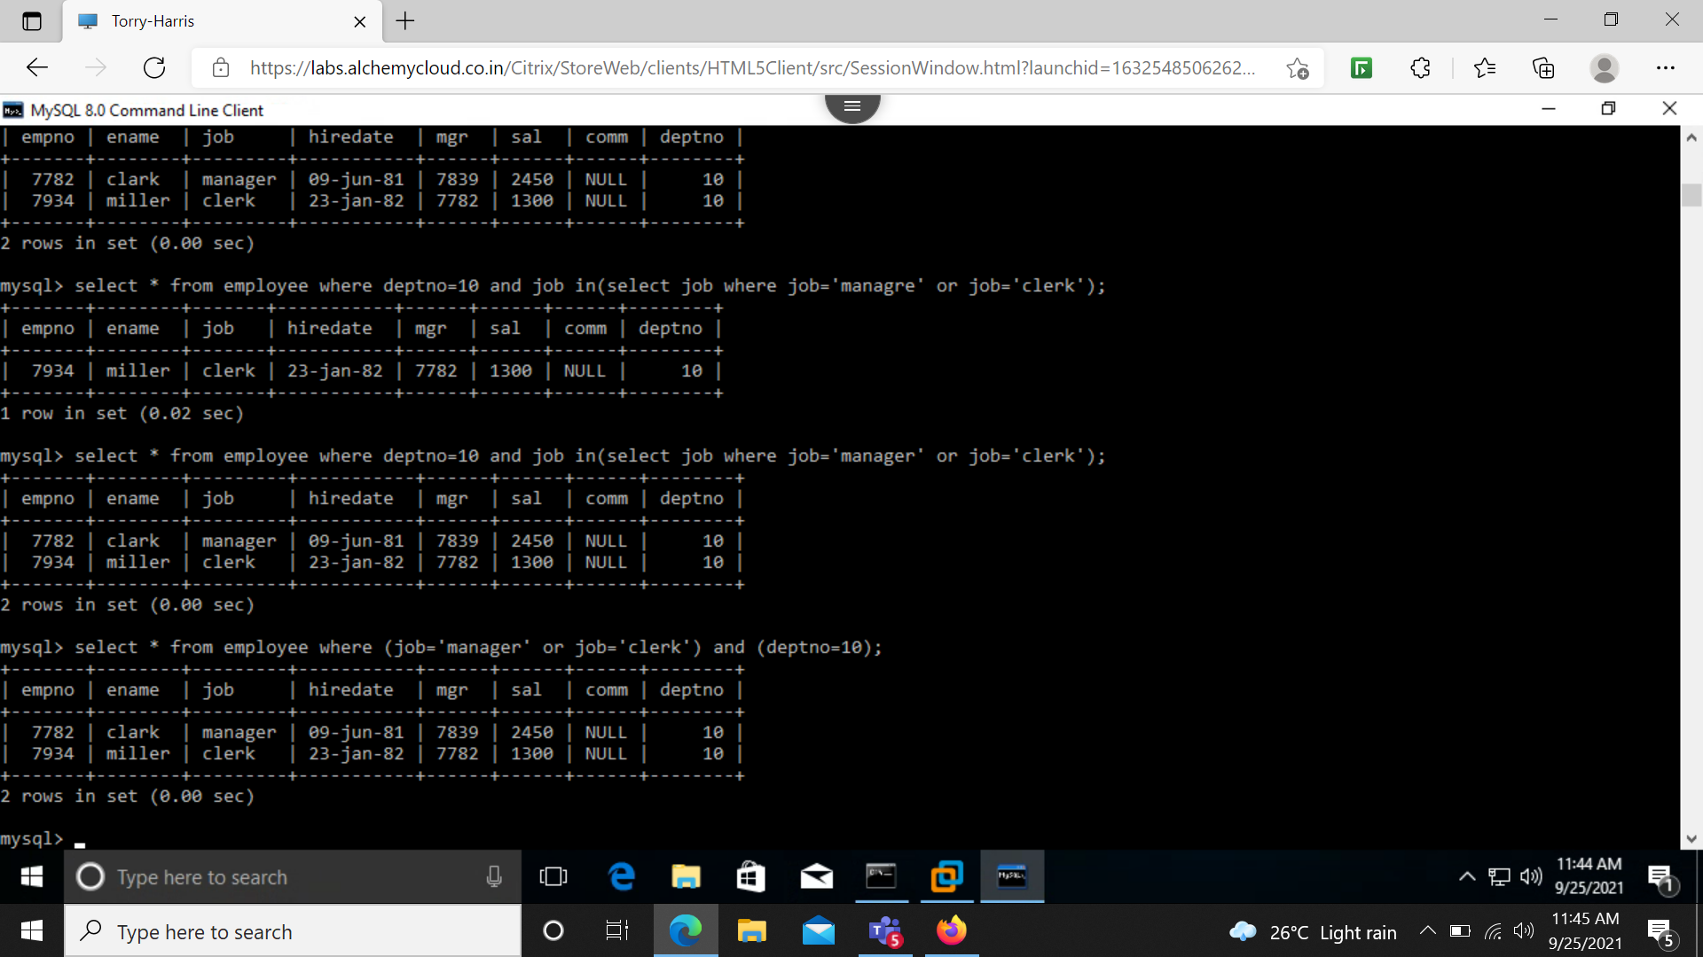

12.Find all the details of all the manager (in any dept) and clerk in dept 20.

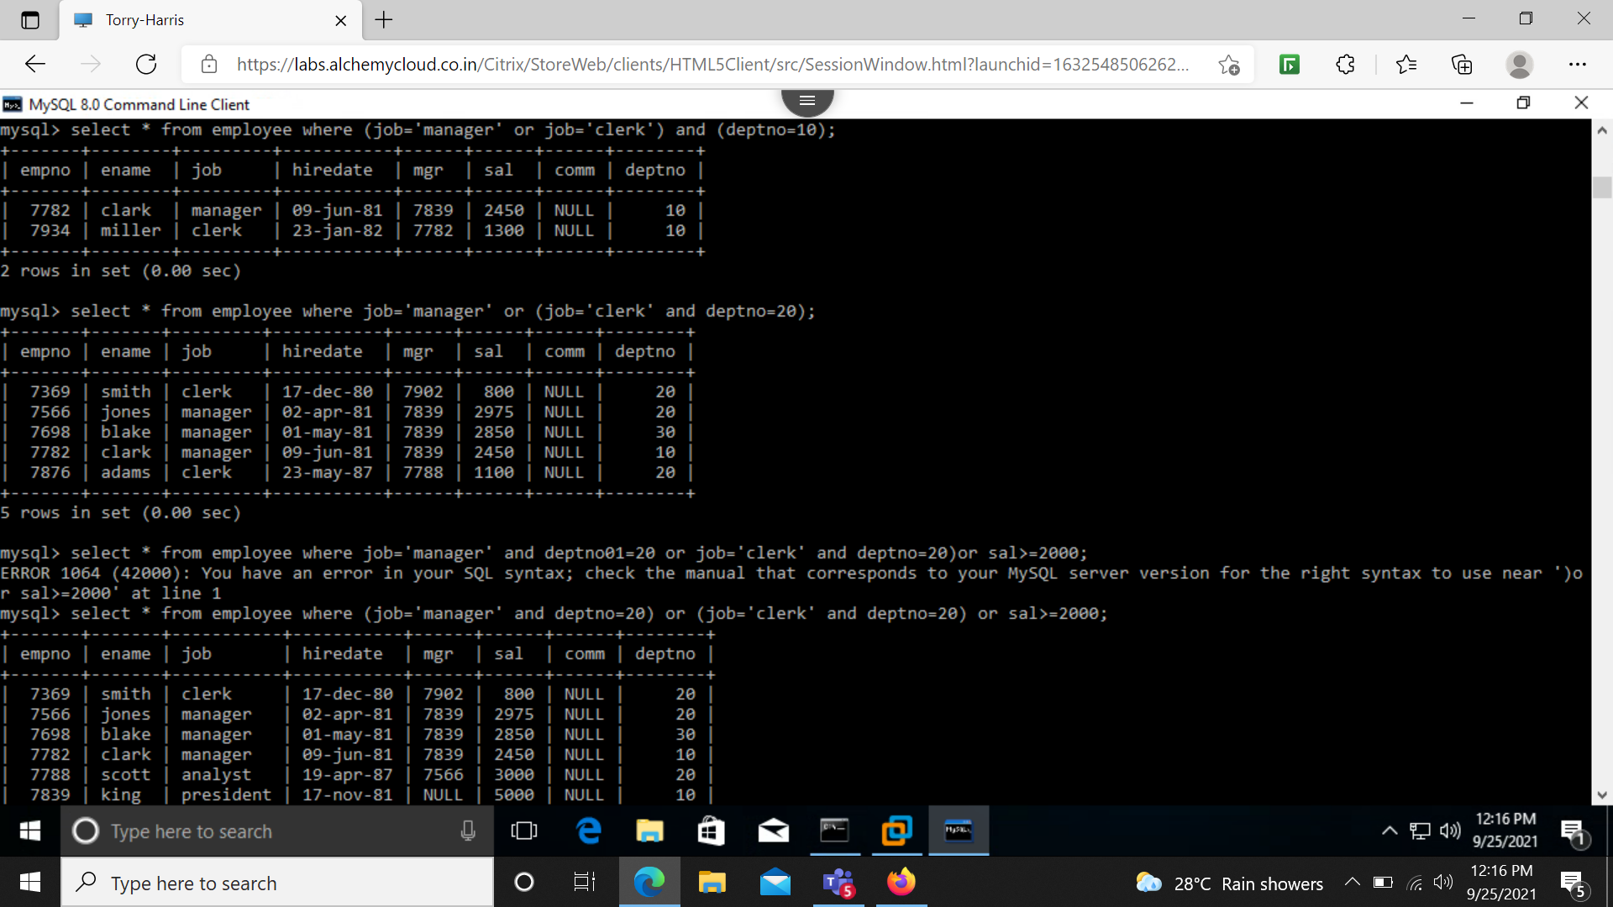

13. Find all the details of all the manager in dept 10 and all clerk in dept 20 and all employees who are neither managers nor clerks but whose salary is more than or equal to 2000/-.

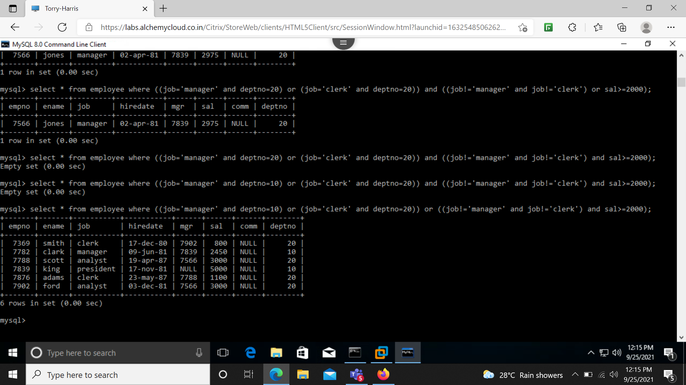

14. Find the names of anyone in dept 20 who is neither manager nor clerk.

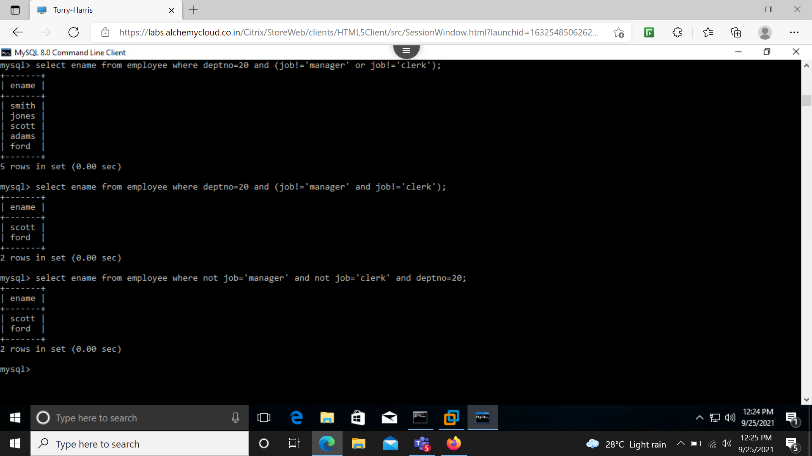

15.find the names of employees who earns between 1200/- and 1400/-.

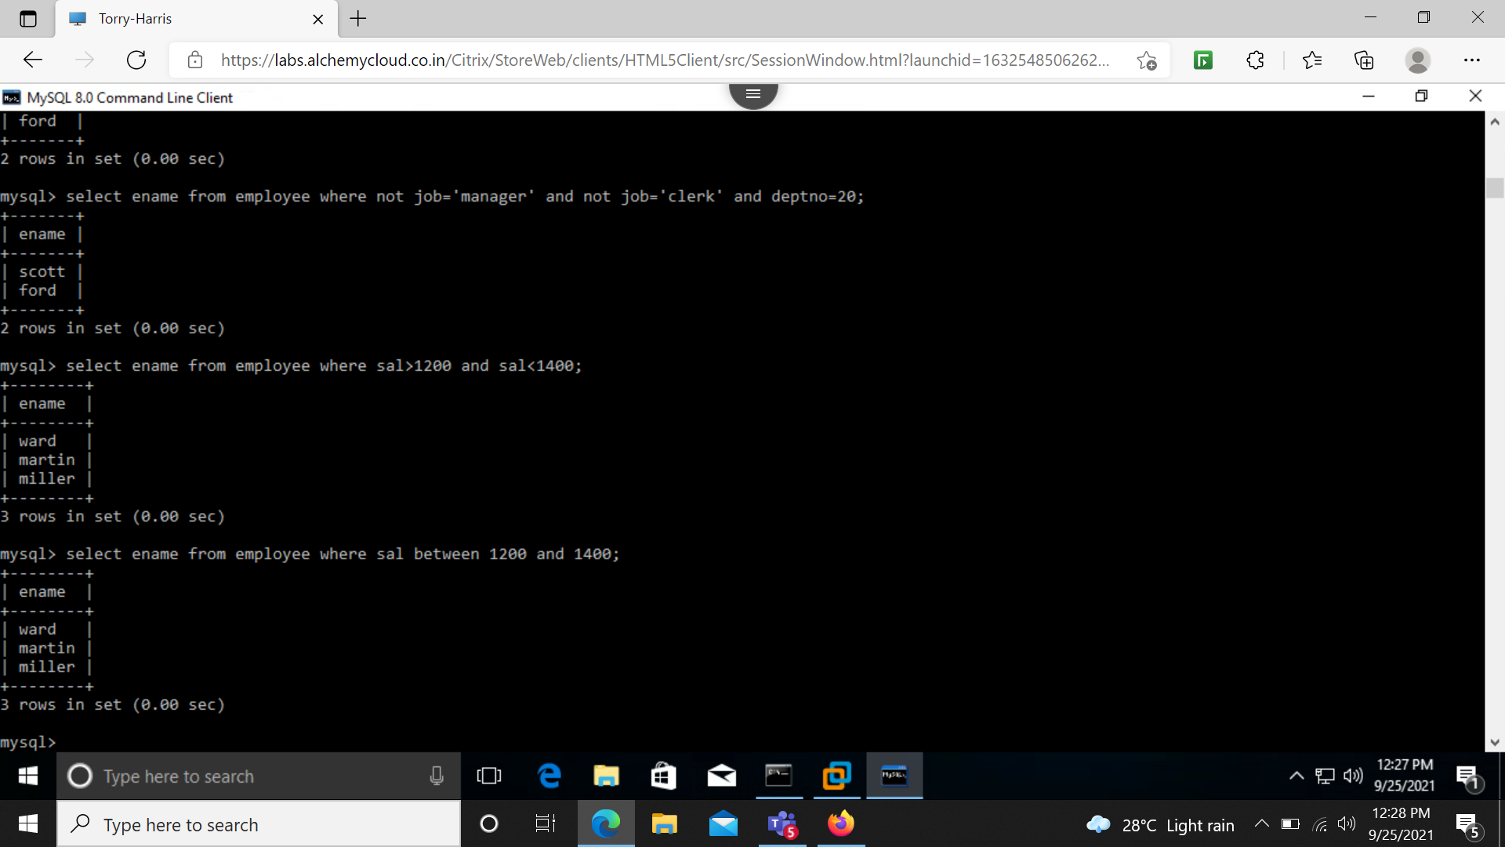

16.find the employees who are clerk,analysts or salesmen.

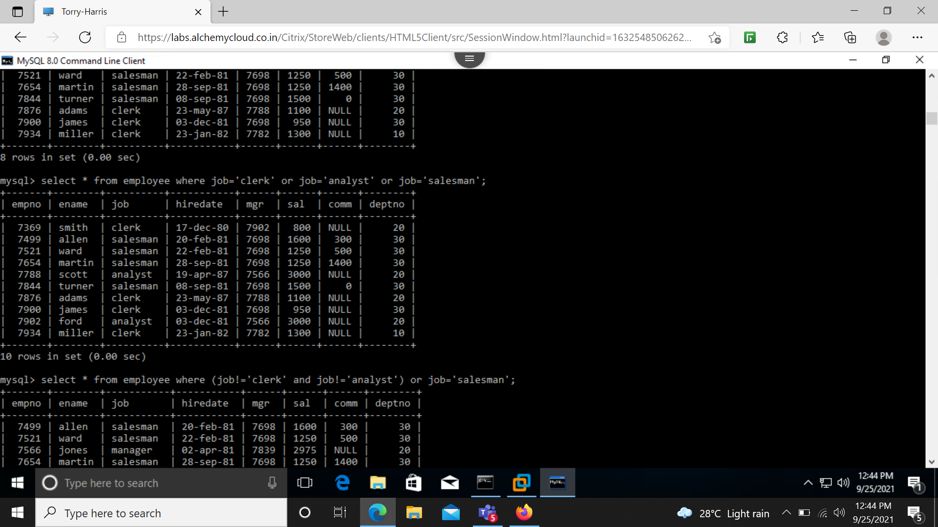

17.find the employees who are not clerk,analysts or salesman.

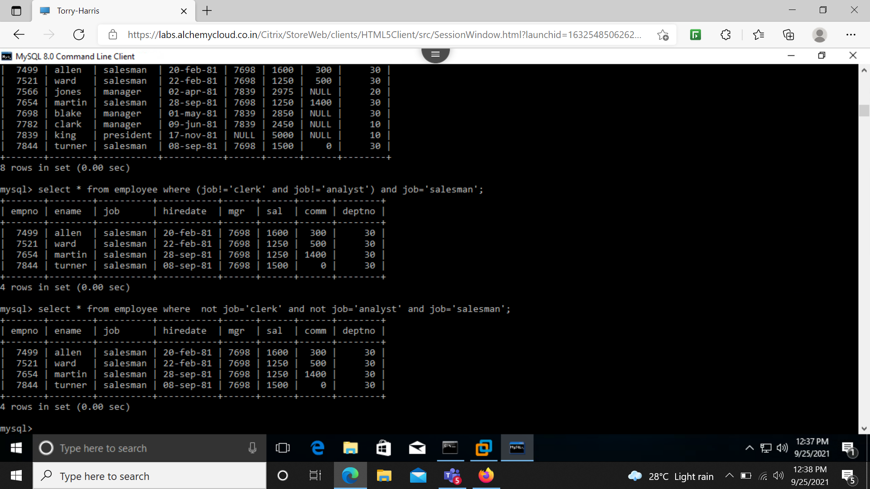

18.find the employees who do not receive commission.

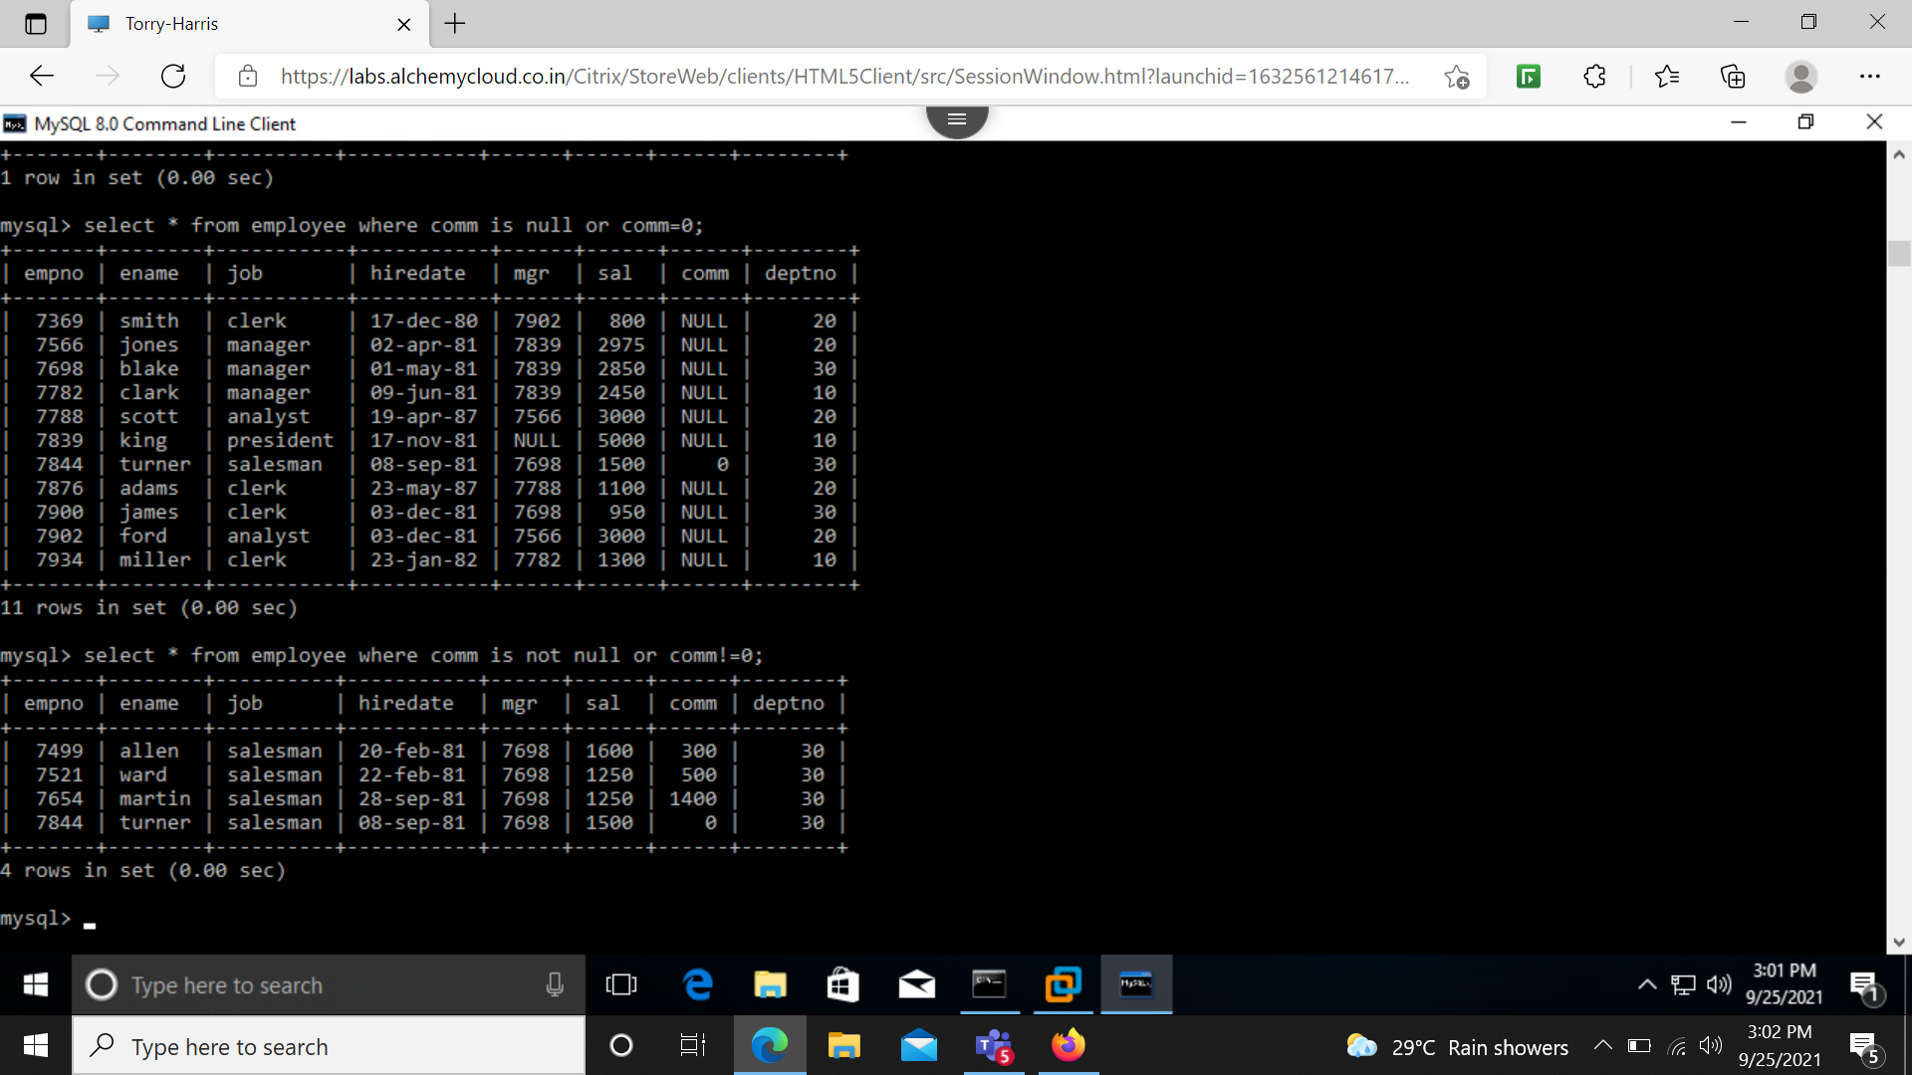

19.find the different job of employee receiving commission.



20.find the employees who do not receive commission or whose commission is less than 1000/-.

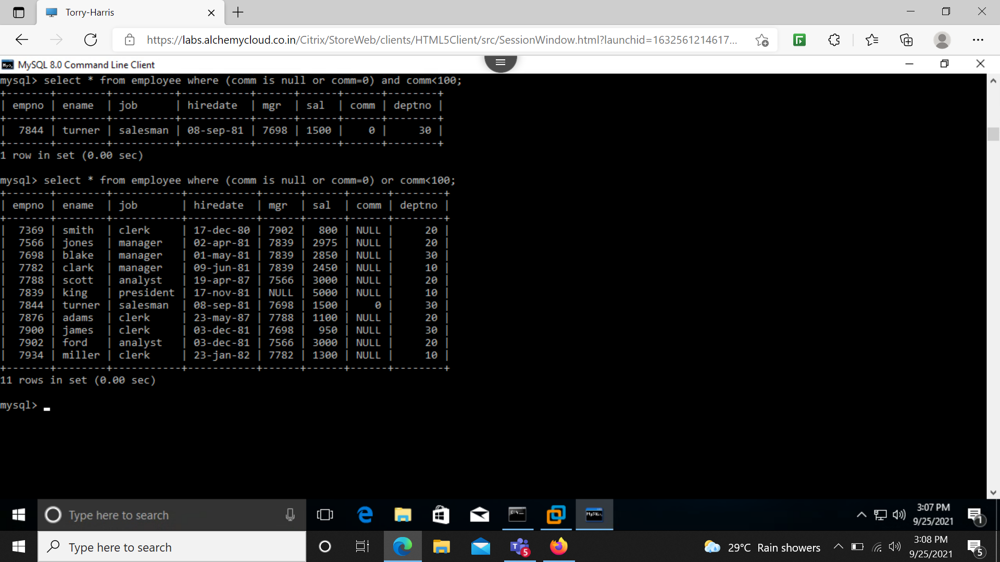

21.if all the employees not receiving commission is entitles to a bonus of Rs.250/- show the net earnings of all the employees.

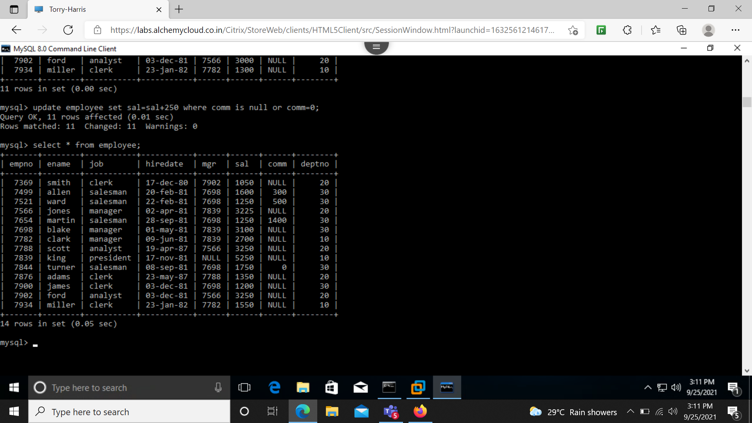

22.Find all the employees whose total earning is greater than 2000/-.

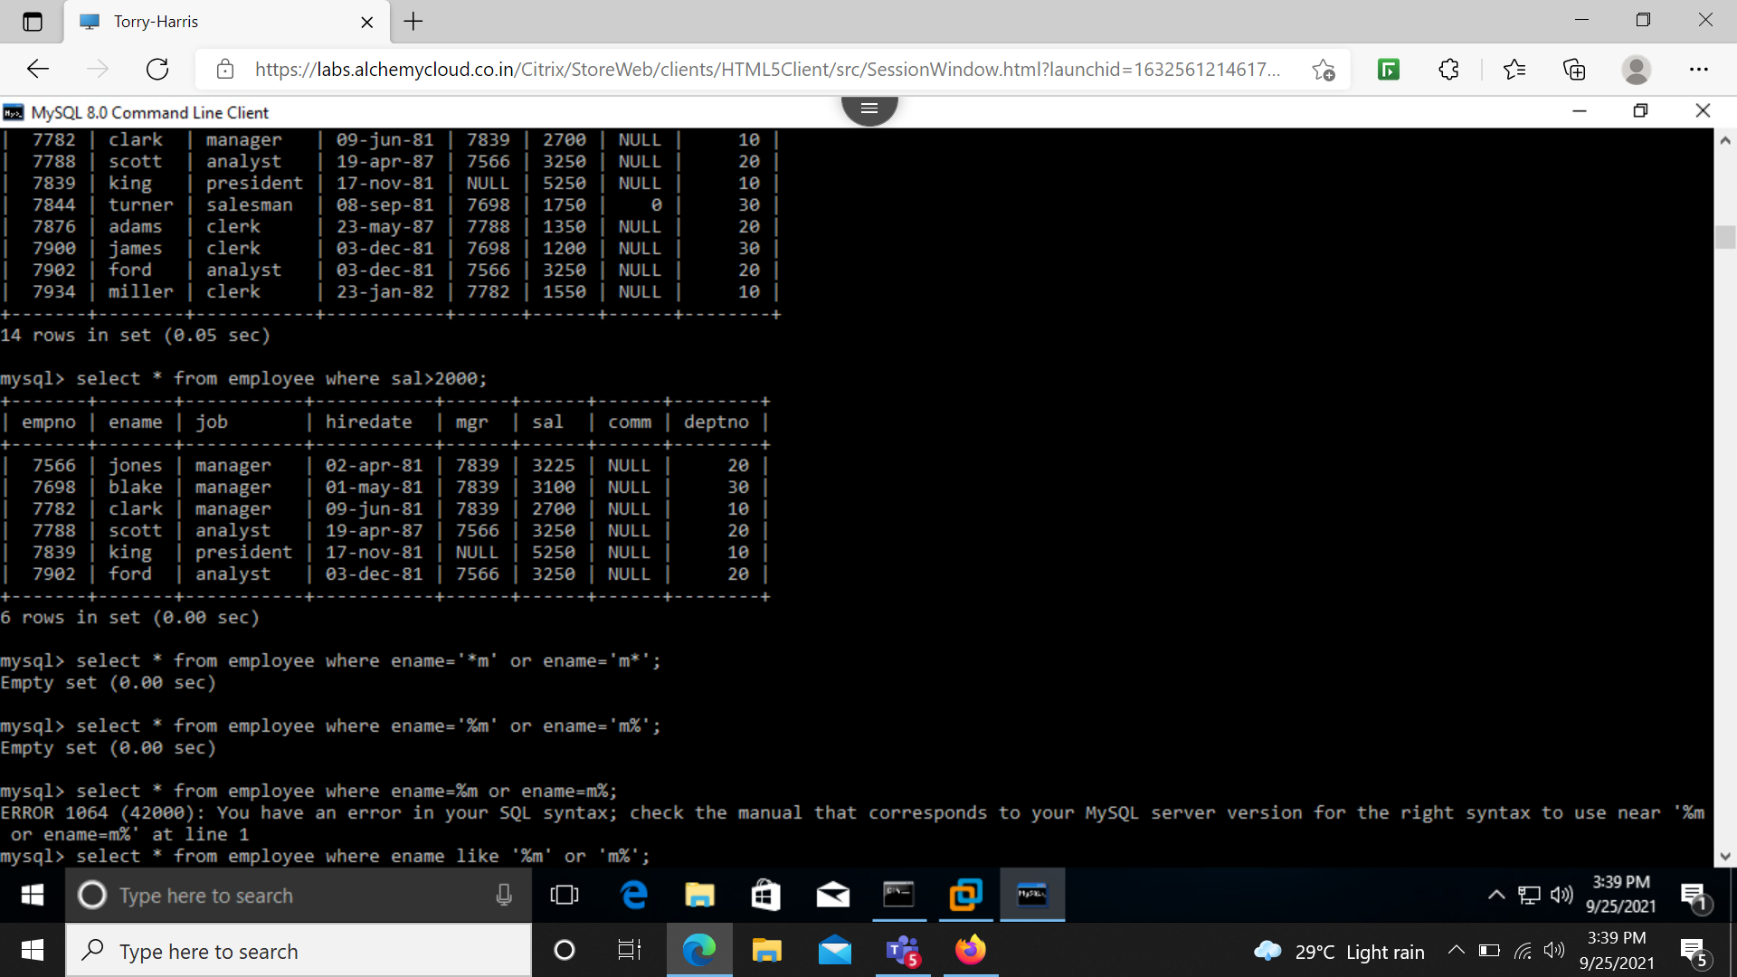

23.find all the employees whose names begins or end with ‘m’.

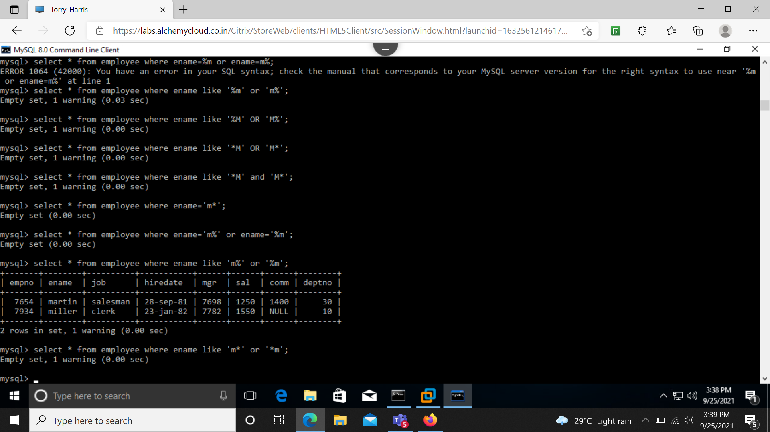

24.find all the employees whose names contain the letter ‘m’ in any case.

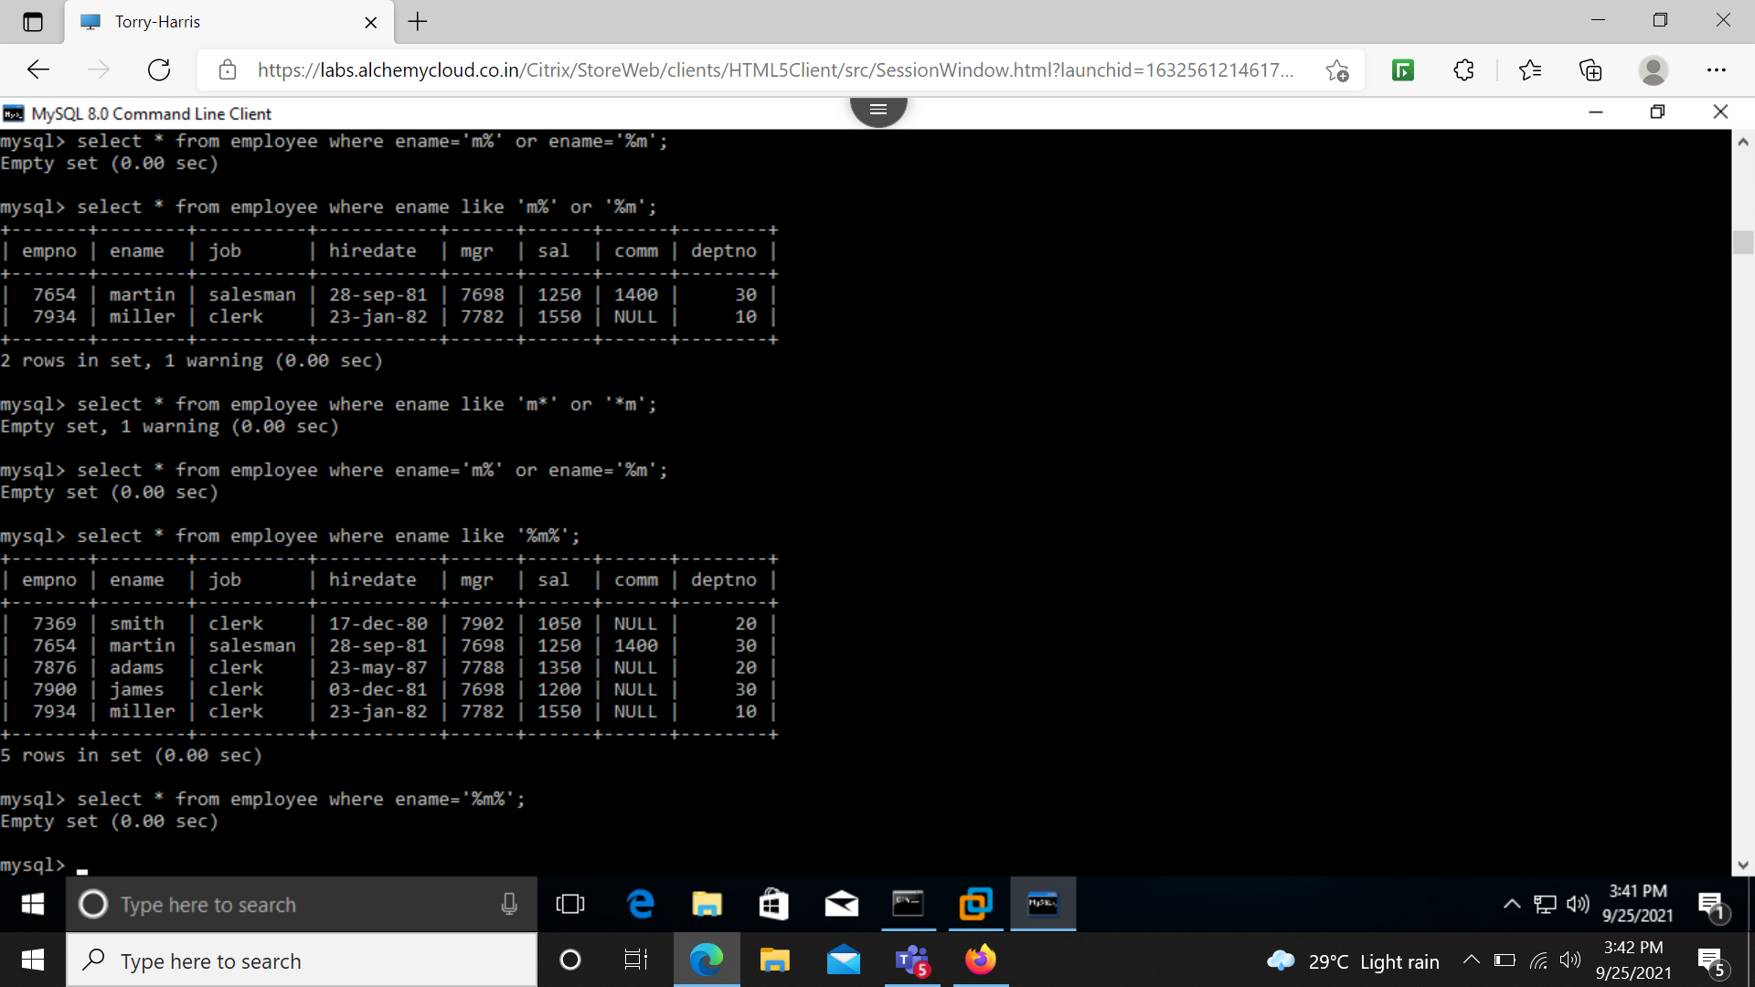

25.find all the employees whose names are upto 15 character long and have letter ‘R’ as 3rd character of their names.

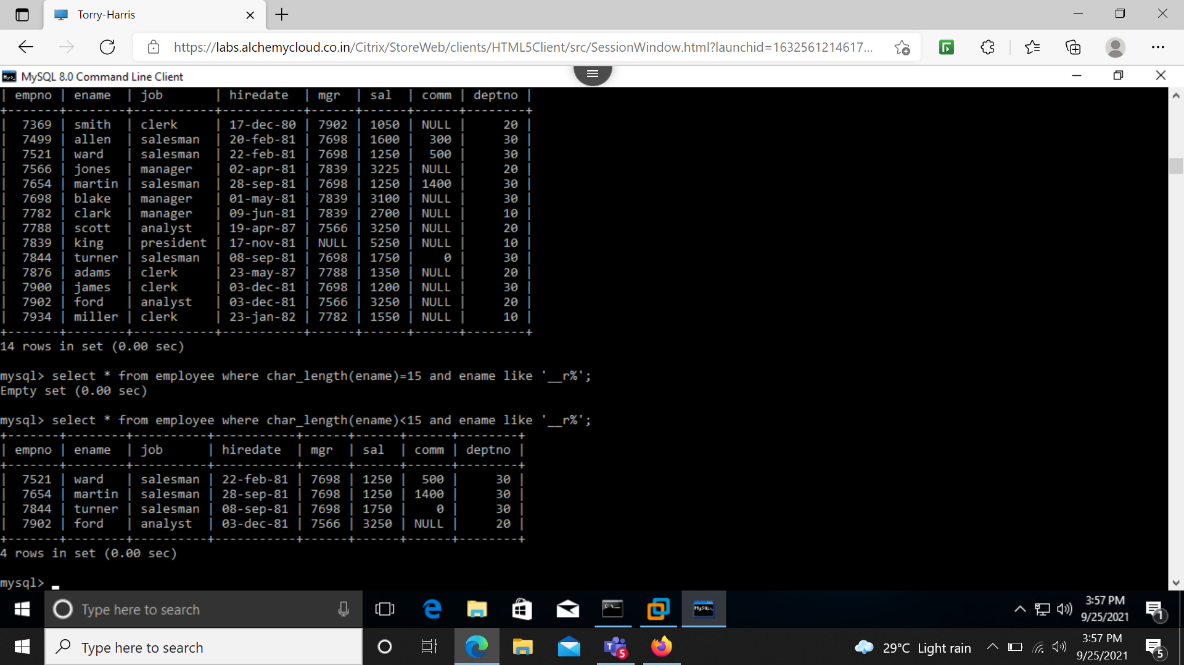

26.find all the employees who were hired in the month of february(of any year).

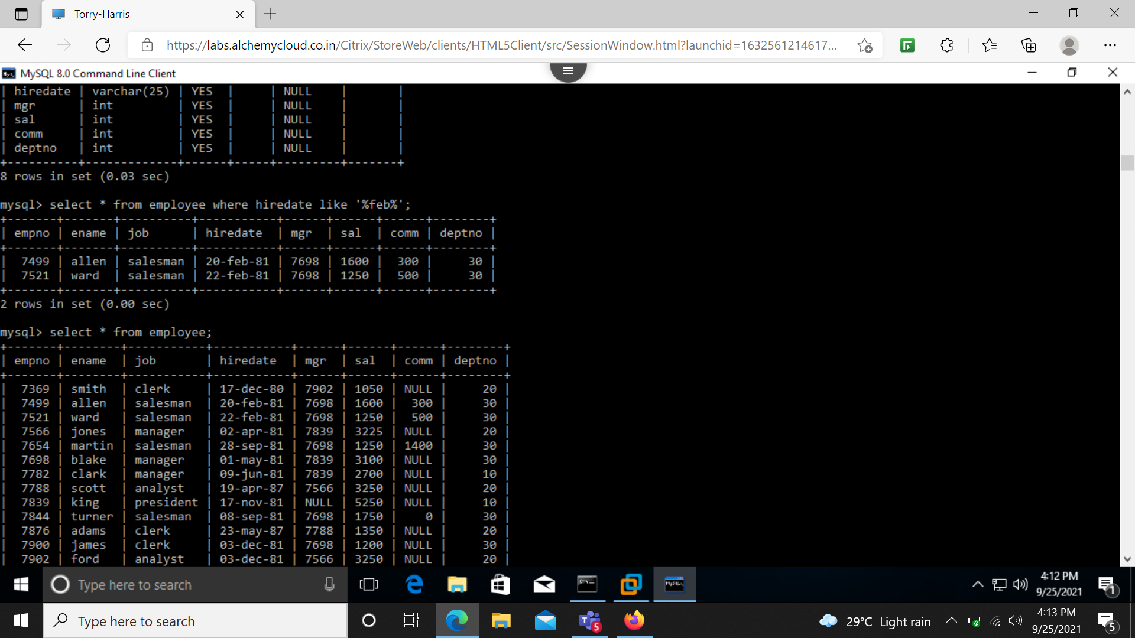

27.find all the employees who were hired on last day of the month.

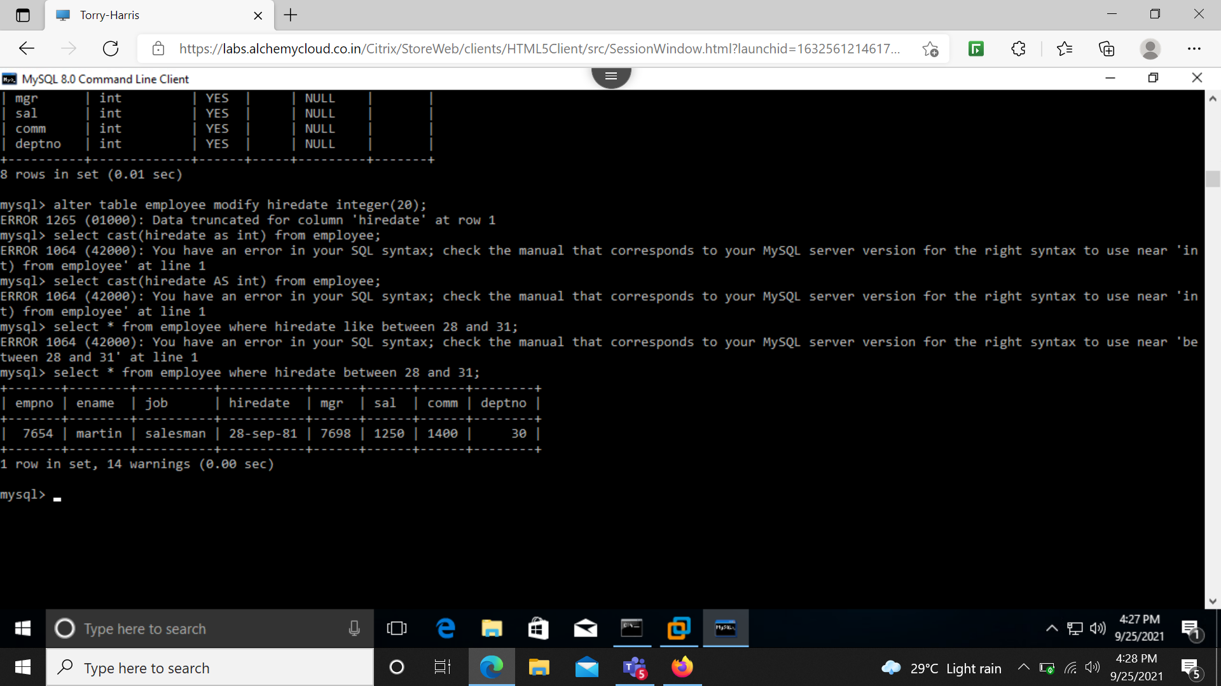

28.find all the employees who were hired more than 2 years ago.

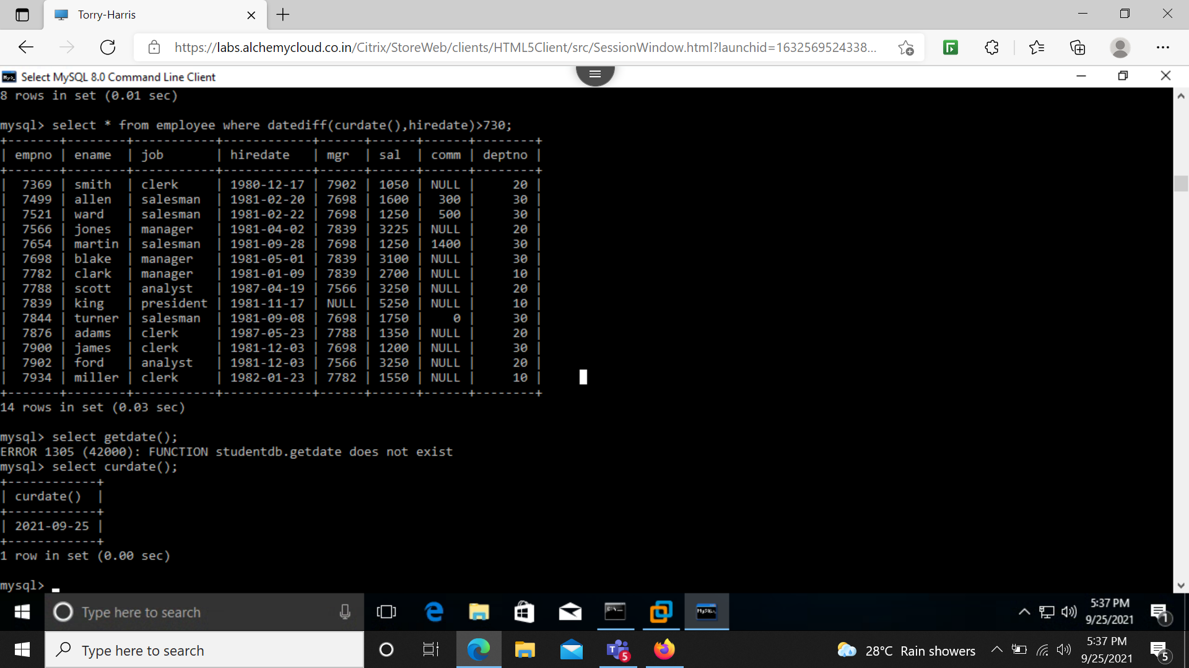

29.find the manager hired in the year 2003

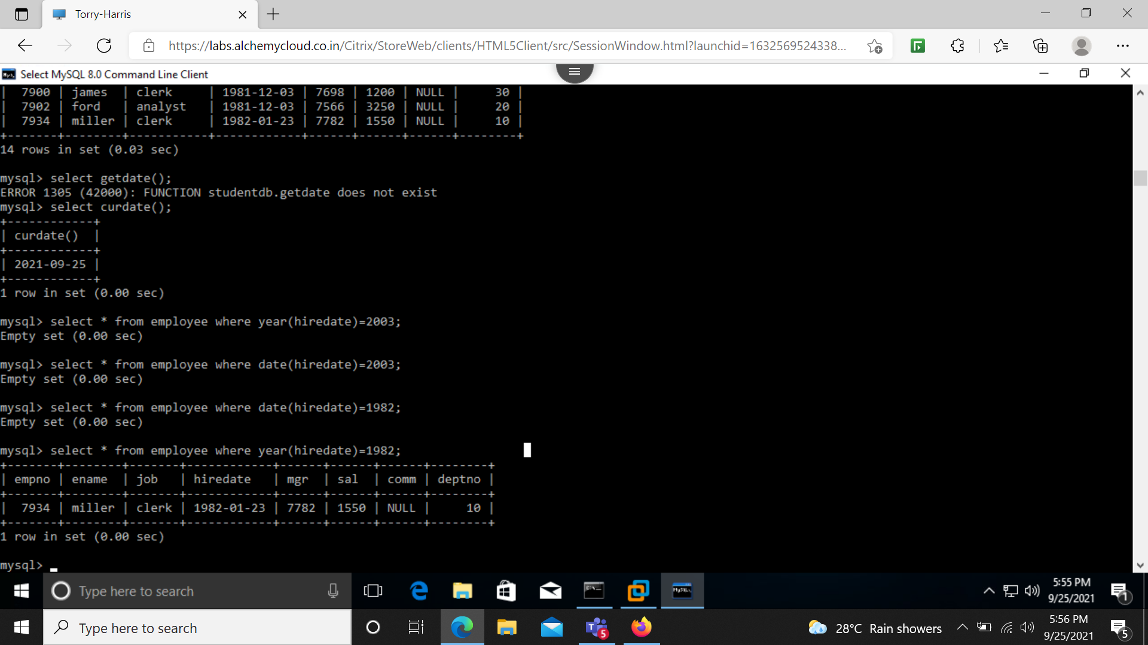

30.Display the names and jobs a of all the employees separated by a space.

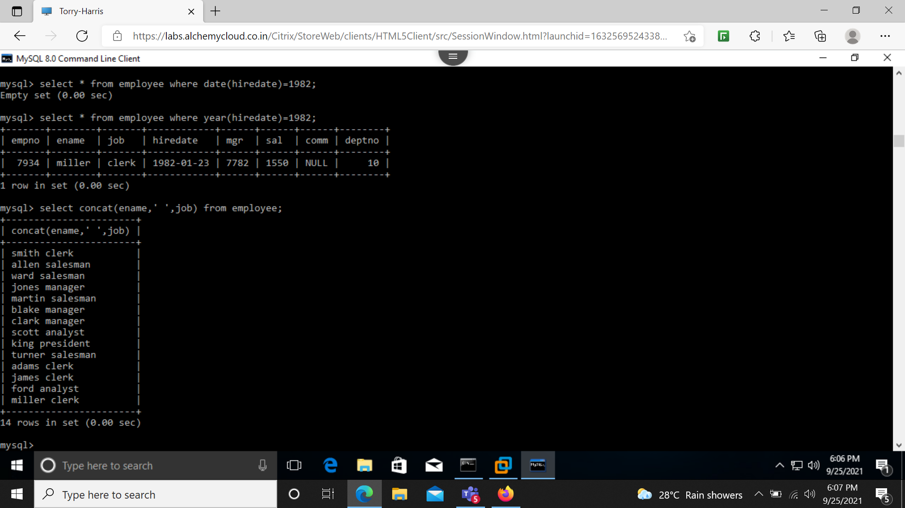

31.display the names of all the employees right aligning them to 15 charaters.

32.dispaly the names of all the employess padding them to the right up to 15 character with ‘\*’.

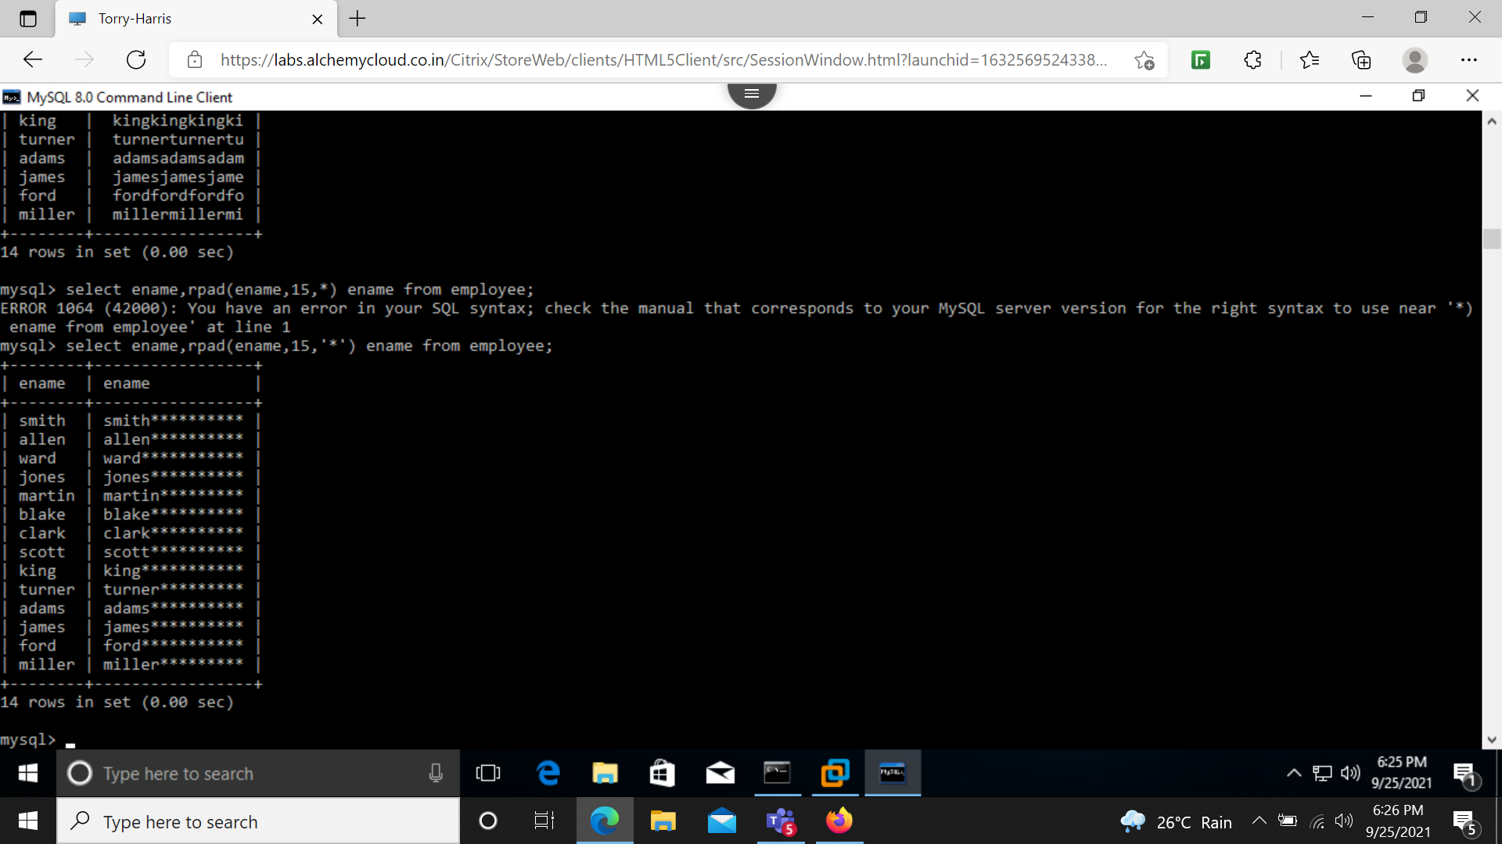

33.display the names of all the employees without any leading ‘A’.

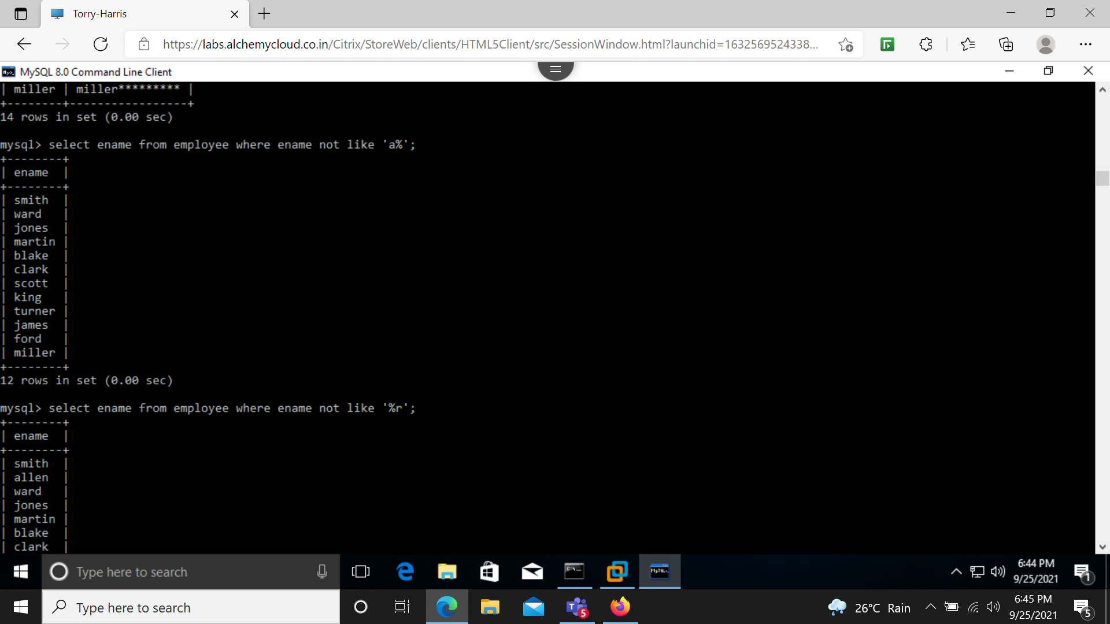

34.display the names of all the employees without any trailing‘R’.

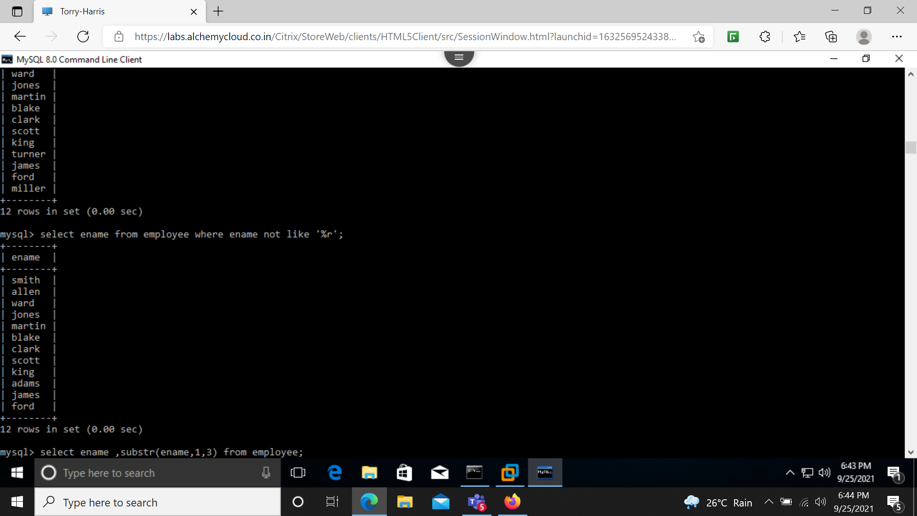

35.show the first 3 and last 3 character of the names of all the employees.

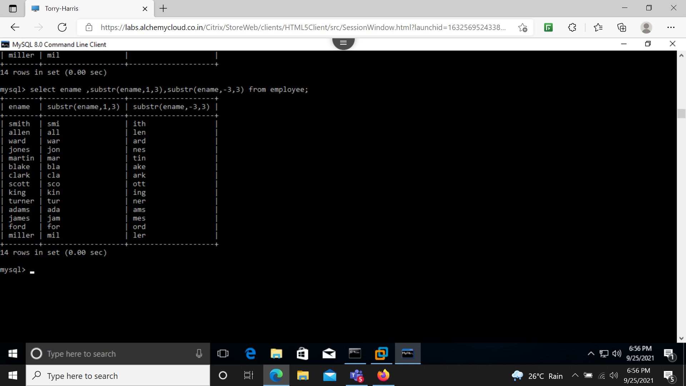

36.display the names of all the employees replacing ‘A’ with ‘a’.

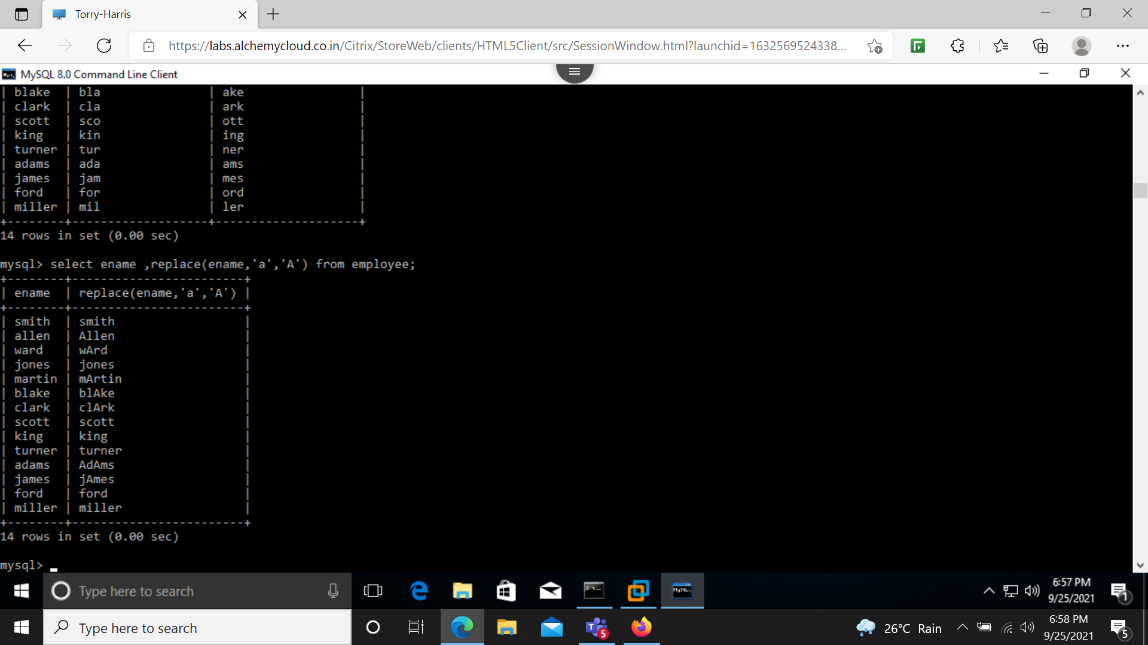

37.display the name of all the employees and position wher the string ‘AR’ occurs in the name.

38.show the salary of all the employees,rounding it to the nearest Rs1000/-.

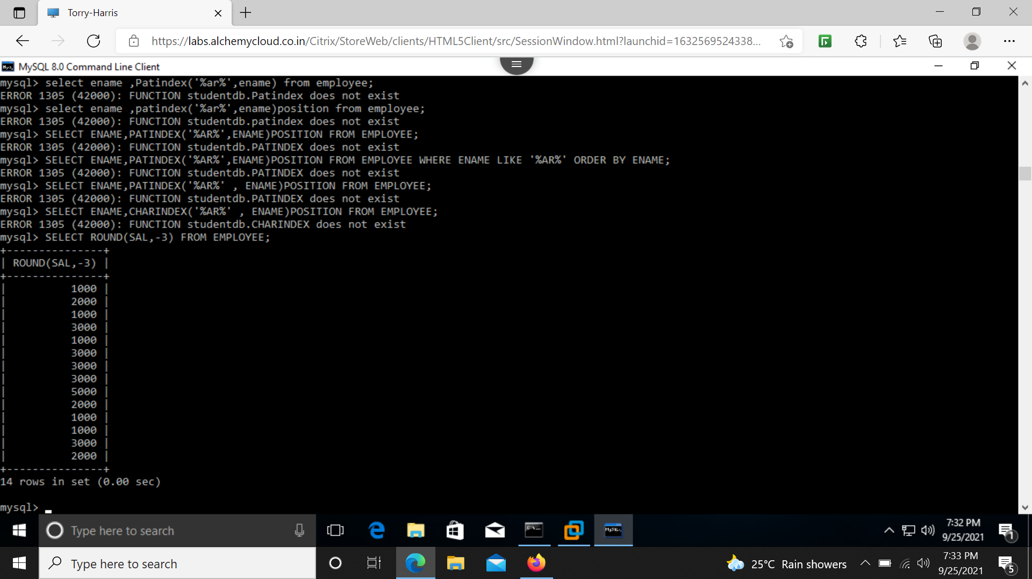

39.show the salary of all the employees ,ignoring the fraction less than Rs1000/-

40.show the names of all the employees and date on which they completed 3 years of service .

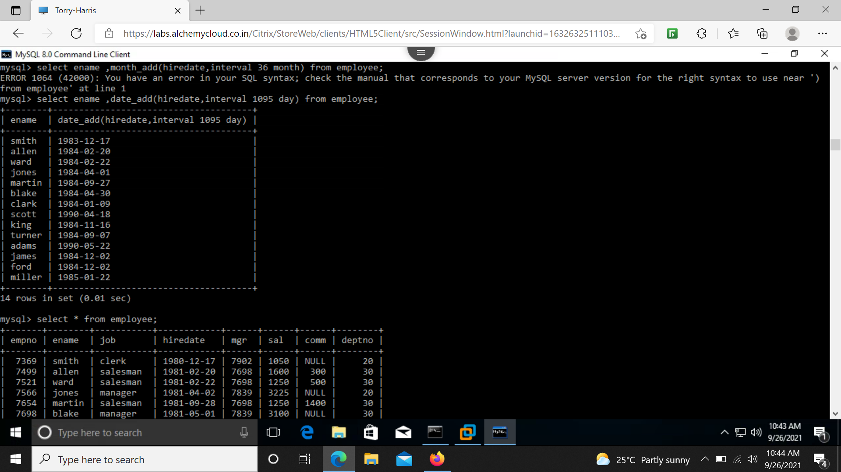

41.for each employee ,display the no. Of days passed since the employee joined the company.

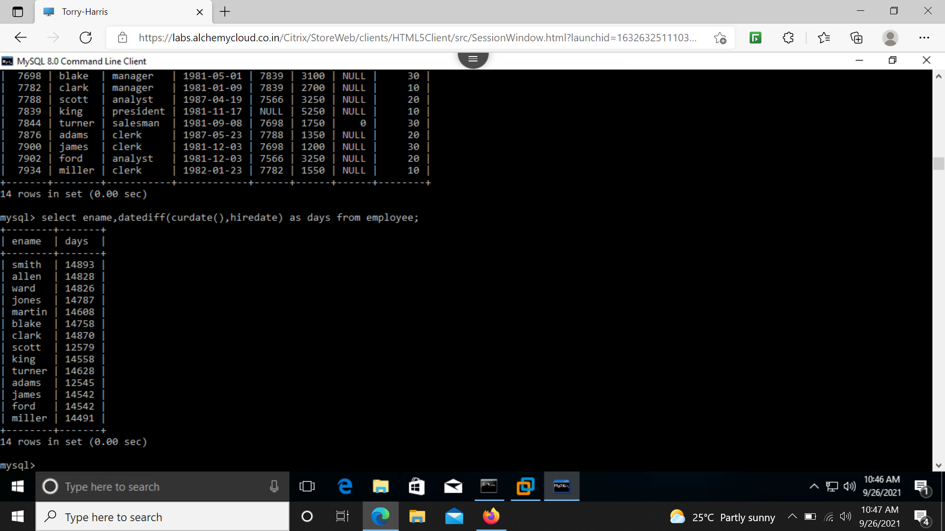

42.For each employee display the no. Of months passed since the employee joined the company.

43.Display the details of all the employees sorted on the names.

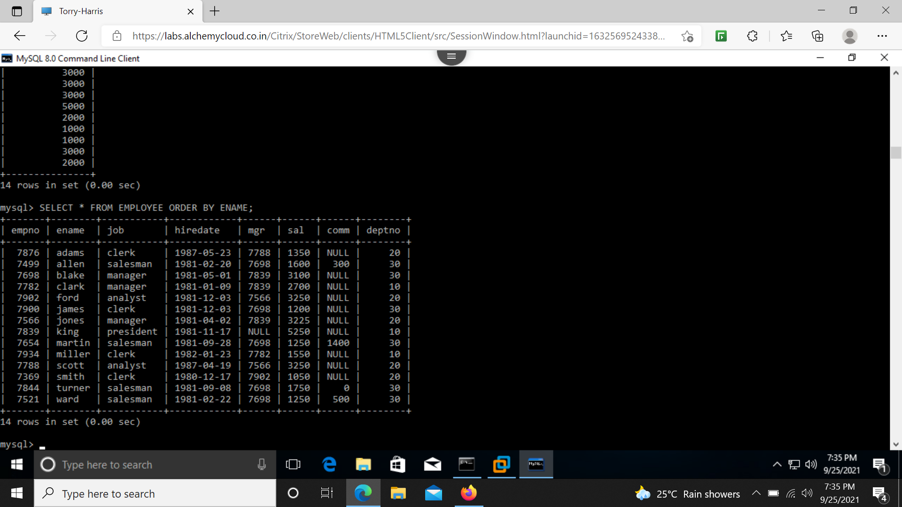

44.Display the names of employees ,based on the tenure with the with the oldest employee coming first.

45.Display the names ,jobs and salaries of employees,sorting on job and salary.

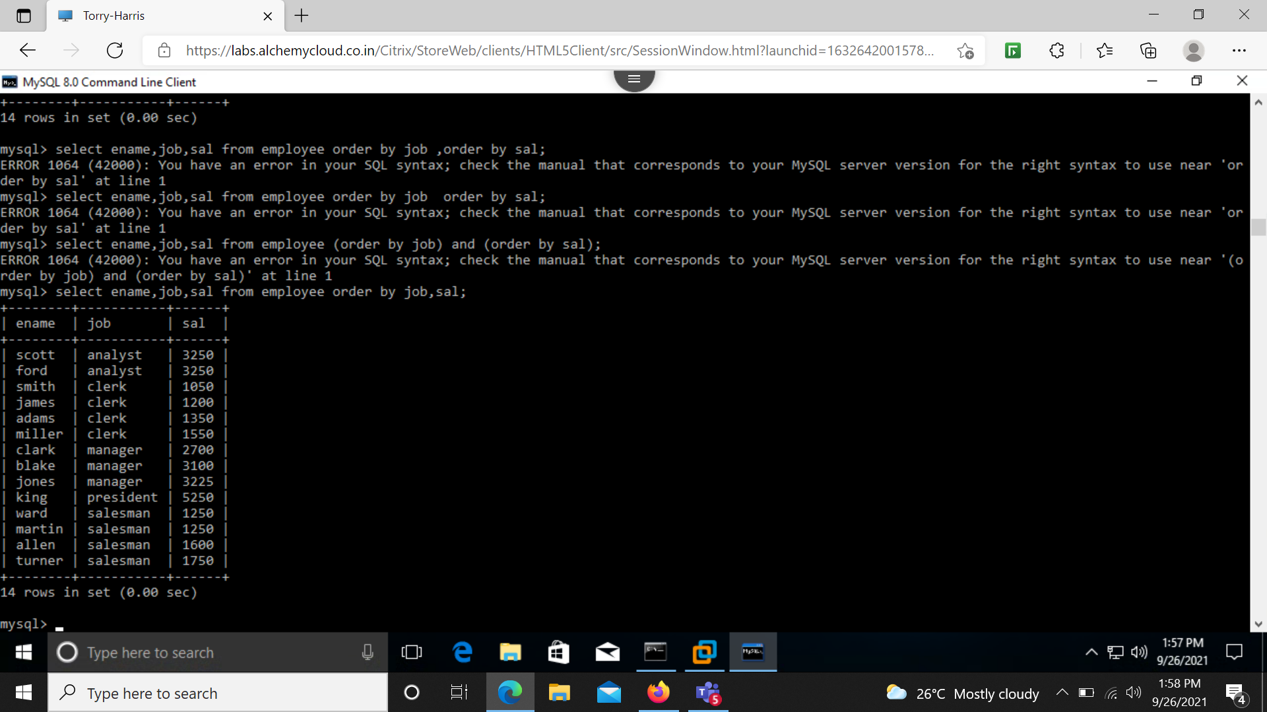

46. Display the names ,jobs and salaries of employees,sorting on descending order of job and within job sorted on salary.

47.List the employees names,department names and salary for those employees who have completed 1 year of service.

48.List the employees names,department names and salary for those employees who are earning 0 commission or commission is null,sort your output in the order of department name.

49.List the employees names,department names and hiredate for those employees who joined in 2003,sort your output int order of joining date.

50.List all the department names along with the names of employees in them irrespective of the fact whether any employee is there or not.